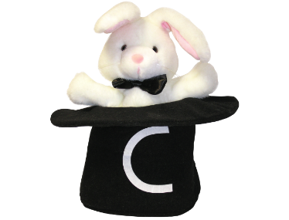Name:

Practice these “Magic C” letters and words

c

a

o

d

g

dog cag